Welcome to Miss Noel’s Preschool!
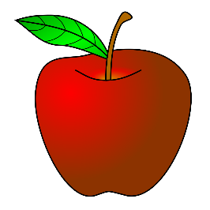
I am very excited to start the school year with you and your child! Preschool children are at a critical developmental period in their lives. In this preschool program parents/guardians, teachers, and children will work together to help the child grow individually in a safe and fun environment. The children will gain knowledge and skills through play and structured activities in the classroom. We respect individual strengths, needs, abilities, and learning styles.
This is your child’s first year in school. We, as teachers want to start your child’s education career off right. In order to do this we need your help! You have already taught your child many things and you will continue to be their most important teacher. With strong communication and teamwork, we will build a good beginning in school.
Other things you can do to help your child succeed in preschool are: start their day off with a healthy breakfast or lunch, send in a healthy snack with your child, and encourage your child in everything they are learning!
These are some of the things we will do in Preschool:
* Sing * Science Experiments * Make Friends * Listen to stories * Paint * Cook * Cut and glue * Cooperate * Act out Stories * Play in sand * Do puzzles and blocks * Dress up * Respect ourselves * Respect others * Play in water

